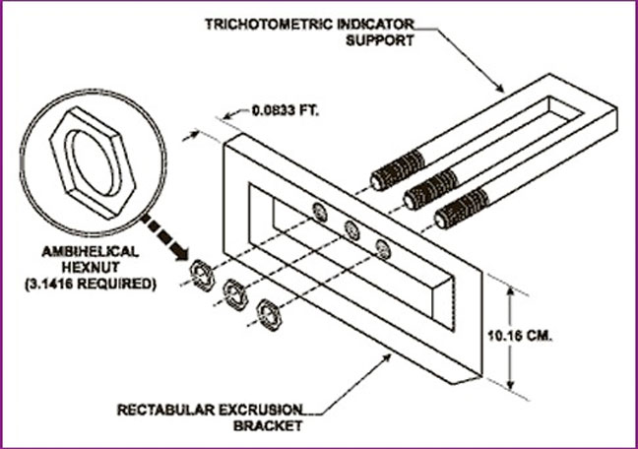

There are many reasons why this set of instructions is not good. The main reason why it is not good is mainly because there are no actually instructions being shown. There are no step by steps given for the reader to use in order to complete their goal. In fact, it is unclear on what the instructions are even for. The fact that there is not even the slightest bit of communication makes this a failure. Also, the pictures do not serve as good visuals from the readers’ perspective. Assuming this is an instruction set for assembling something, the necessary tools are not listed. This causes even more confusion for the reader because they do not know what tools they need in order to assemble the parts. This instruction set is completely unclear and confusing that it is nearly impossible for readers to even fathom what the writer is instructing them to do.

